
YJK Technologies

HCM -Requirement

Preface
This guide provides comprehensive information required to configure and use the Human Capital Management (HCM) system effectively within your organization. It is designed to help HR professionals, administrators, and end-users understand and utilize the system’s capabilities to manage recruitment and employee self-service processes efficiently.
The HR system supports a wide range of recruitment and interview management activities through structured screens and dashboards, including:
- Recruitment Management
- Interview Master
- Interview Dashboard
- Interview Schedule Report
- Interview Feedback Report
- Candidate Interview Report
- Panel Performance Report
- Hiring Decision Report
- Total Candidates Applied
- Total Interviews Scheduled
- Interview Completion Rate
In addition, the system enables streamlined Employee Self-Service (ESS) functionalities, allowing employees to manage their personal and professional information independently.

C H A P T E R

Introduction
The Requirement Screens in the HR system are designed to streamline and manage the end-to-end recruitment and interview process in an efficient and structured manner. These screens provide HR teams, hiring managers, and interview panels with the necessary tools to track candidate progress, schedule interviews, collect feedback, and make informed hiring decisions.
The system includes a set of integrated modules that work together to ensure transparency, accuracy, and ease of use throughout the recruitment lifecycle. Each screen is designed with user-friendly navigation and real-time data updates to support quick decision-making.

Key Requirement Screens
The following screens are part of the recruitment and interview management process:
- Recruitment: Manages job openings, candidate applications, and recruitment workflows.
- Interview Master: Maintains interview configurations such as interview types, rounds, and panel details.
1. Job Master
2. Candidate Master
3. Interview Panel
4. Panel Members
5. Interview schedule
6. Interview Feedback
7. Interview Decision
- Interview Dashboard: Provides a consolidated view of all interview activities and key metrics.
- Interview Schedule Report: Displays scheduled interviews with date, time, and panel information.
- Interview Feedback Report: Captures and tracks feedback provided by interviewers.
- Candidate Interview Report: Shows detailed interview history and performance of candidates.
- Panel Performance Report: Evaluates interviewer performance and effectiveness.
- Hiring Decision Report: Tracks final hiring outcomes and decisions.

Purpose of Requirement Screens
The primary objectives of these screens are to:
- Simplify recruitment and interview management
- Provide centralized access to candidate and interview data
- Enable structured evaluation and feedback collection
- Support data-driven hiring decisions through reports and dashboards

C H A P T E R

Interview Master

✧ The Interview Master module is used to define and manage interview-related configurations within the recruitment system.
✧ It serves as a central setup screen where users can configure key elements required for conducting interviews, such as:
- Interview Types (e.g., Technical, HR, Managerial)
- Interview Rounds (e.g., Round 1, Round 2, Final Round)
- Panel Details (interview panel structure and assignment)
✧ This module ensures that all interview processes are standardized and structured across the system.
Navigation
✧ The Interview Master module is part of the recruitment workflow, which includes:
- Job Master
- Candidate Master
- Interview Panel
- Panel Members
- Interview Schedule
- Interview Feedback
- Interview Decision
✧ These modules work together to support the complete hiring lifecycle from job creation to final candidate selection.
Functionality
✧ The Interview Master module allows users to:
- Configure different interview types based on organizational needs
- Define multiple interview rounds for a job
- Assign or manage interview panel structures
- Maintain consistency in interview processes
✧ The configured data is used in downstream modules such as:
- Interview Scheduling
- Interview Feedback
- Interview Decision

Job Master:
✧ The Job Master screen enables users to create, manage, and maintain job-related information within the system. It acts as the primary source for defining job positions used throughout the recruitment process.
Selecting the “Job Master” tab from the main navigation bar directs the user to the Job Master screen.
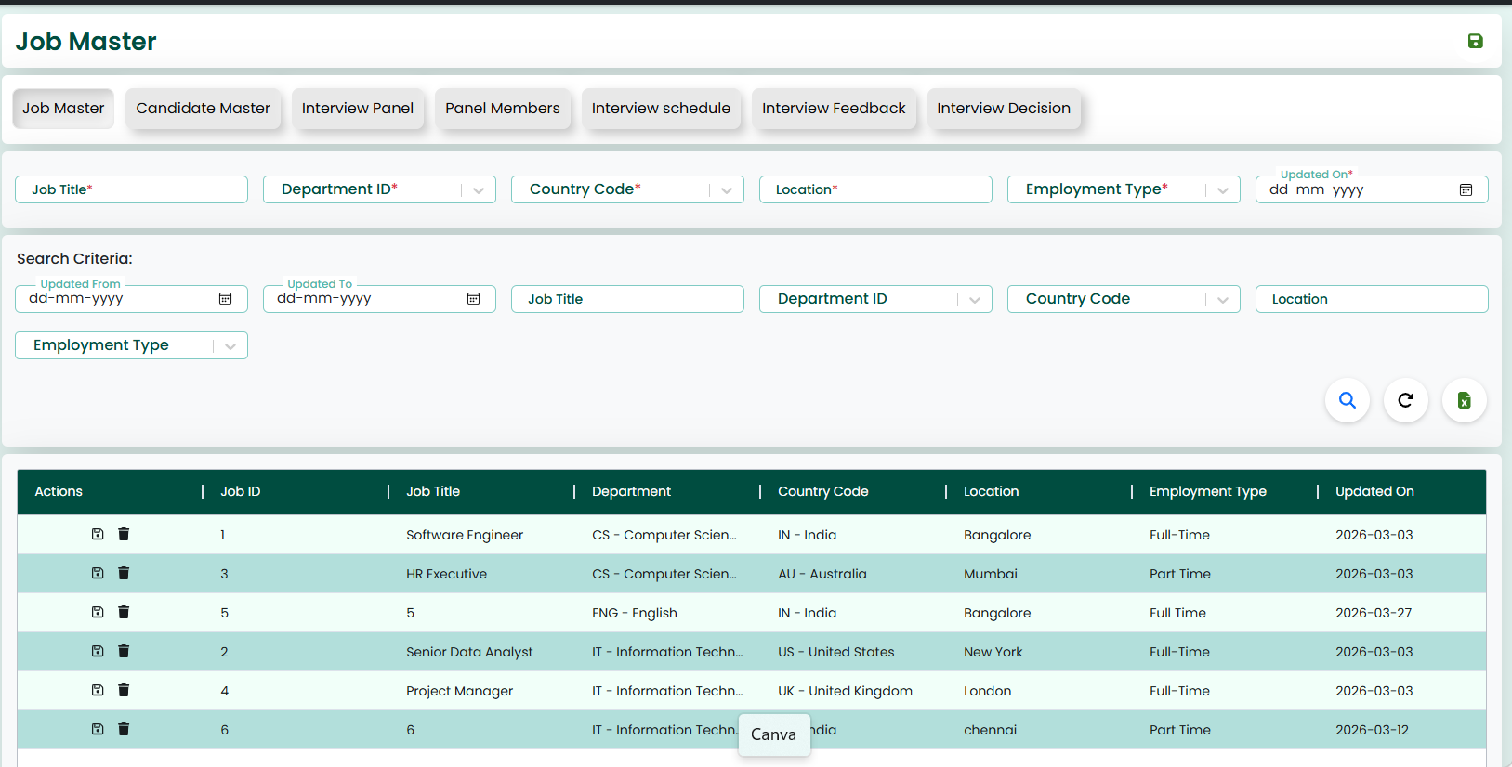
✧ The image shown above illustrates the Job Master screen.
✧This screen is used to enter and manage job-related details such as Job Title, Department ID, Country Code, Location, Employment Type, and Updated On.
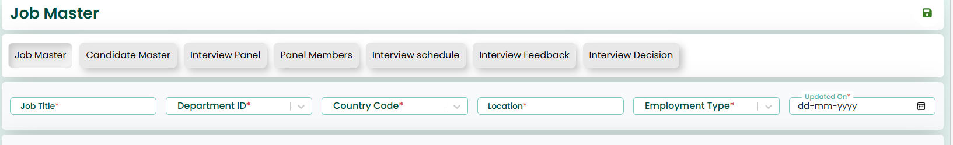
Action Button:
✧ This screen also features 'Save' and 'Reload' buttons located at the top-right corner.
✧ On this screen, the user must enter all the required job details. After entering the data, by clicking the 'Save' button, the job details will be saved in the system.
✧ All mandatory fields are marked with (*). The user must fill these fields before saving the data.
Search Criteria
✧ This screen provides a Search Criteria section to retrieve existing job records.
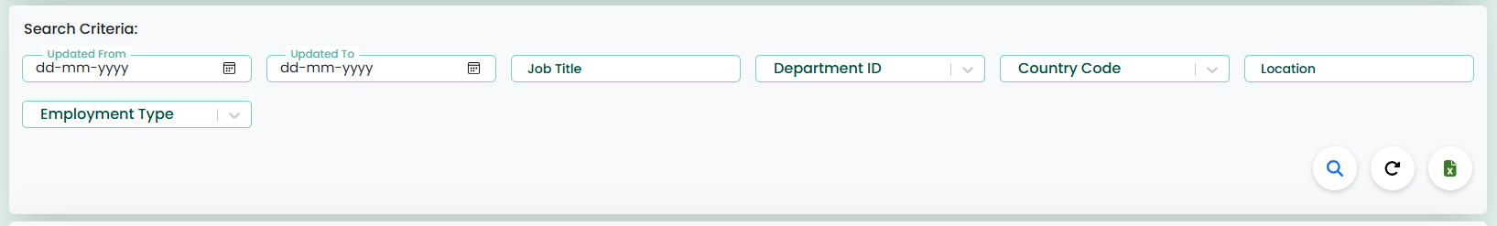
✧ The user can search the job data using the following fields:
- Updated From
- Updated To
- Job Title
- Department ID
- Country Code
- Location
- Employment Type

✧ After entering the search criteria, clicking the Search icon will display the matching job records.
Action Button
✧ The Reload icon clears all search fields and reloads the data.
✧ The Excel icon is used to export the displayed job records into an Excel file.
Data Grid
✧ The saved job records are displayed in the grid below the search section.
✧ The grid shows details such as Job ID, Job Title, Department, Country Code, Location, Employment Type, and Updated On.
✧ When the user selects a record from the grid, the data will be loaded into the screen.
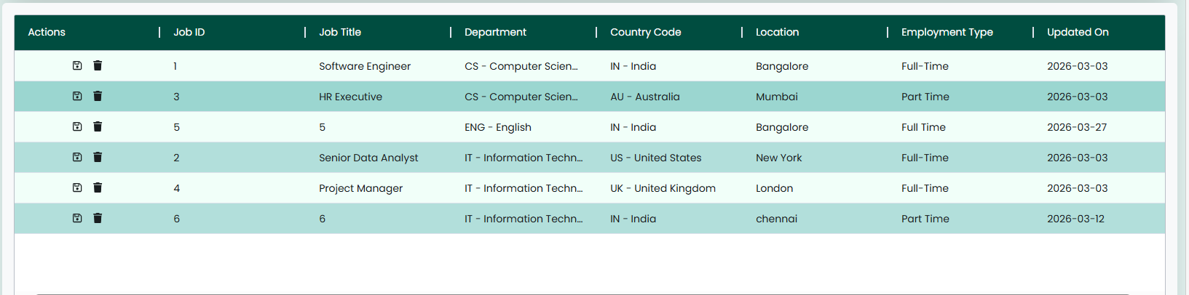

Action Button:
✧ Once the data is fetched, if the user wants to update or delete it, "Update" and "Delete" buttons will appear on the right side. These allow the user to modify or delete the data as needed.
✧ The 'Reload' button can be used to refresh the page, clearing all fields and resetting the screen to its initial state.

Candidate Master:
✧ The Candidate Master screen enables users to create, manage, and maintain candidate-related information within the system. It acts as the primary source for storing candidate details used throughout the recruitment process.
Selecting the “Candidate Master” tab from the main navigation bar directs the user to the Candidate Master screen.
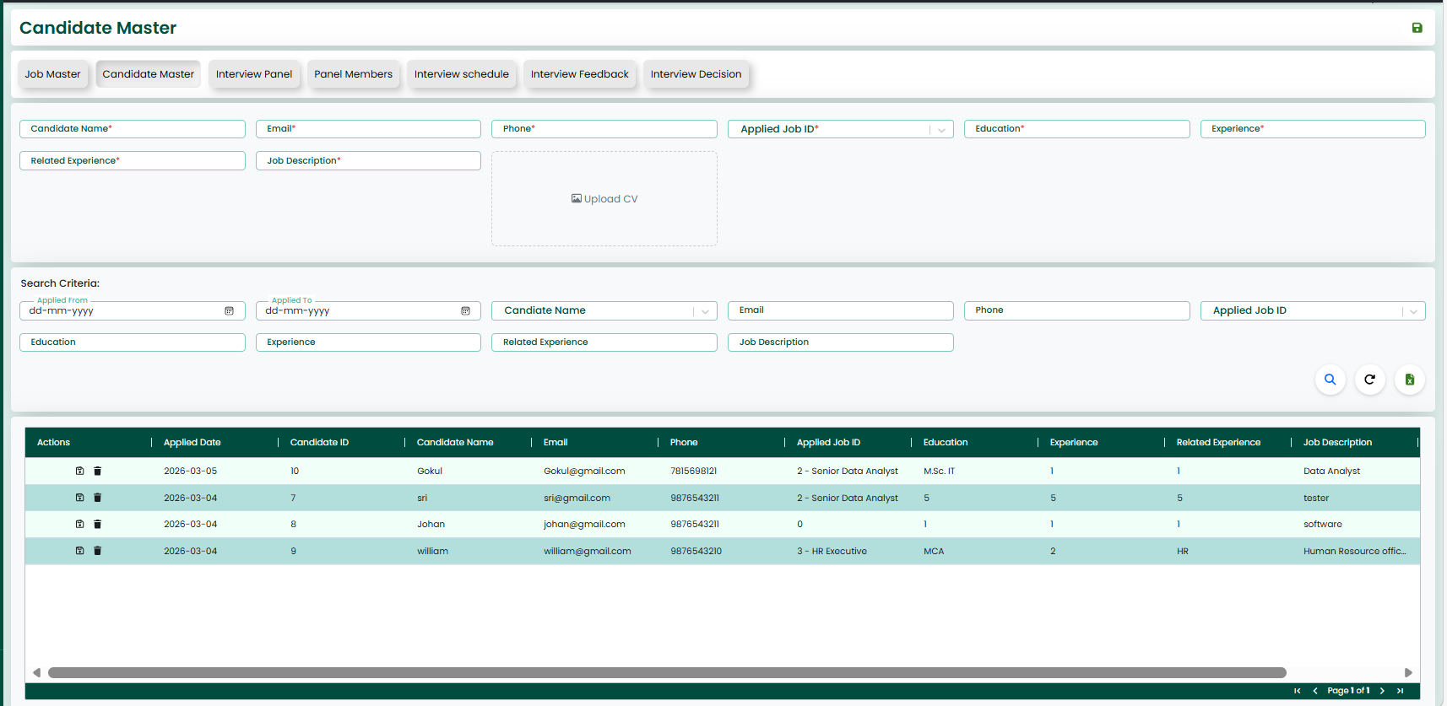
✧ The image shown above illustrates the Candidate Master screen.
✧ This screen is used to enter and manage candidate-related details such as Candidate Name, Email, Phone, Applied Job ID, Education, Experience, Related Experience, Job Description, and Upload CV.
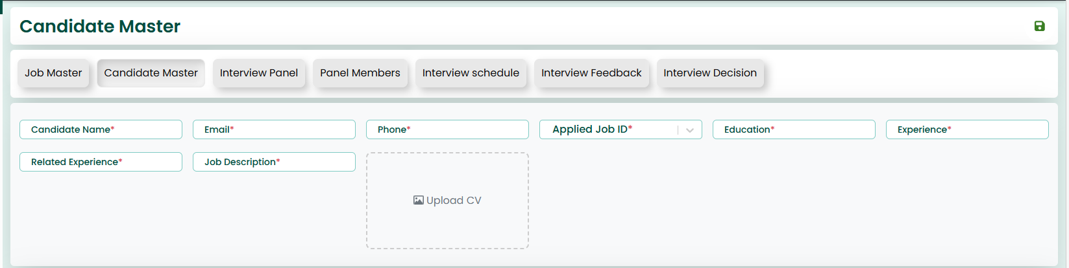

Action Button:
✧ This screen also features 'Save' and 'Reload' buttons located at the top-right corner.
✧ On this screen, the user must enter all the required candidate details. After entering the data, by clicking the 'Save' button, the candidate details will be saved in the system.
✧ All mandatory fields are marked with (*). The user must fill these fields before saving the data.

Search Criteria
✧ This screen provides a Search Criteria section to retrieve existing candidate records.
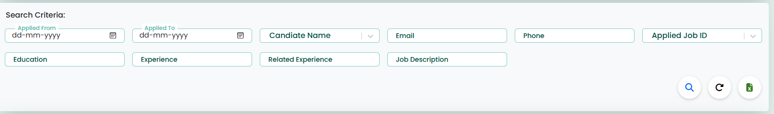
✧ The user can search the candidate data using the following fields:
Applied From
Applied To
Candidate Name
Email
Phone
Applied Job ID
Education
Experience
Related Experience
Job Description
✧ After entering the search criteria, clicking the Search icon will display the matching candidate records.
Action Button
✧ The Reload icon clears all search fields and reloads the data.
✧ The Excel icon is used to export the displayed candidate records into an Excel file.
Data Grid
✧ The saved candidate records are displayed in the grid below the search section.
✧ The grid shows details such as Candidate Name, Email, Phone, Applied Job ID, Education, Experience, Related Experience, and Job Description.
✧ When the user selects a record from the grid, the data will be loaded into the screen.
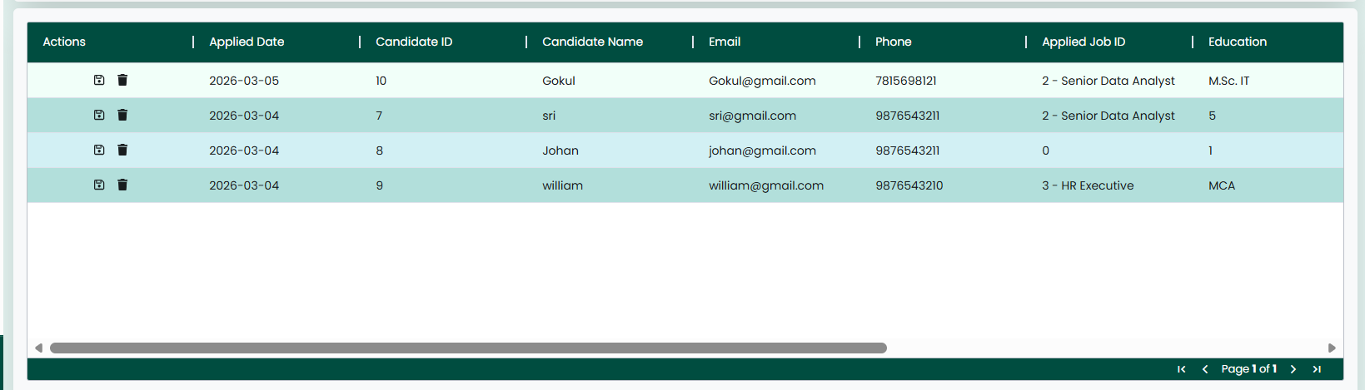
Action Button:
✧ Once the data is fetched, if the user wants to update or delete it, "Update" and "Delete" buttons will appear on the right side. These allow the user to modify or delete the data as needed.
✧ The 'Reload' button can be used to refresh the page, clearing all fields and resetting the screen to its initial state.
Interview Panel:
✧ The Interview Panel screen enables users to create, manage, and maintain panel-related information within the system. It is used to define interview panels for specific job positions and departments.
Selecting the “Interview Panel” tab from the main navigation bar directs the user to the Interview Panel screen.
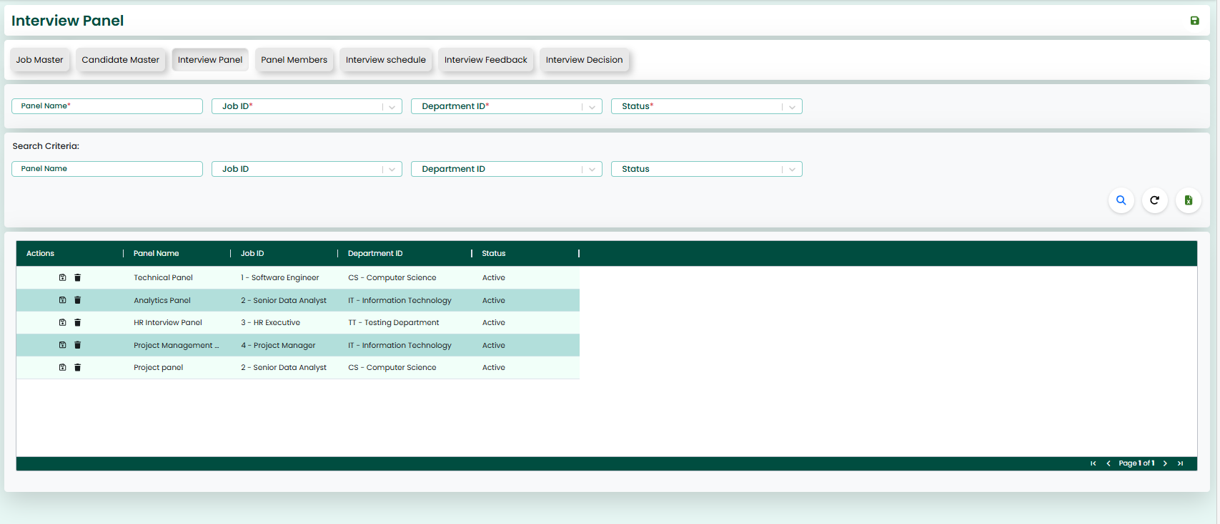
✧ The image shown above illustrates the Interview Panel screen.
✧ This screen is used to enter and manage panel-related details such as Panel Name, Job ID, Department ID, and Status.
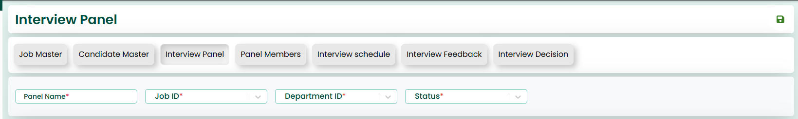
Action Button:
✧ This screen also features 'Save' and 'Reload' buttons located at the top-right corner.
✧ On this screen, the user must enter all the required panel details. After entering the data, by clicking the 'Save' button, the panel details will be saved in the system.
✧ All mandatory fields are marked with (*). The user must fill these fields before saving the data.

Search Criteria
✧ This screen provides a Search Criteria section to retrieve existing panel records.
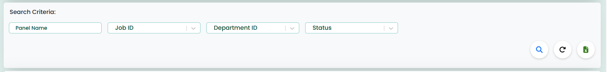
✧ The user can search the panel data using the following fields:
Panel Name
Job ID
Department ID
Status
✧ After entering the search criteria, clicking the Search icon will display the matching panel records.
Action Button
✧ The Reload icon clears all search fields and reloads the data.
✧ The Excel icon is used to export the displayed panel records into an Excel file.
Data Grid
✧ The saved panel records are displayed in the grid below the search section.
✧ The grid shows details such as Panel Name, Job ID, Department ID, and Status.
✧ When the user selects a record from the grid, the data will be loaded into the screen.
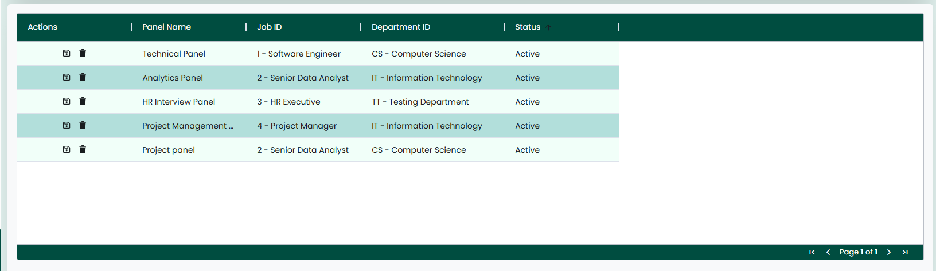
Action Button:
✧ Once the data is fetched, if the user wants to update or delete it, "Update" and "Delete" buttons will appear on the right side. These allow the user to modify or delete the data as needed.
✧ The 'Reload' button can be used to refresh the page, clearing all fields and resetting the screen to its initial state.
Panel Members:
✧ The Panel Members screen enables users to create, manage, and maintain details of members assigned to interview panels within the system. It helps in associating employees with specific panels and defining their roles in the interview process.
Selecting the “Panel Members” tab from the main navigation bar directs the user to the Panel Members screen.
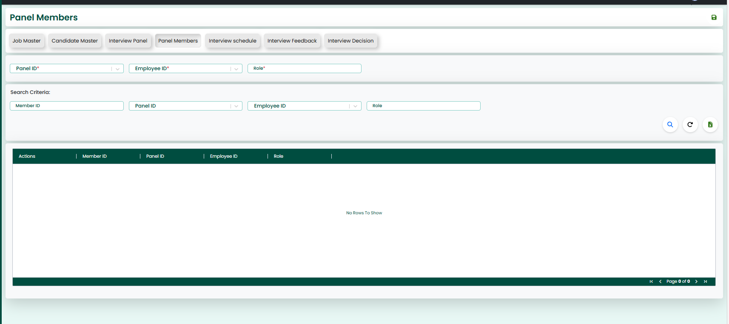
✧ The image shown above illustrates the Panel Members screen.
✧ This screen is used to enter and manage panel member details such as Panel ID, Employee ID, and Role.
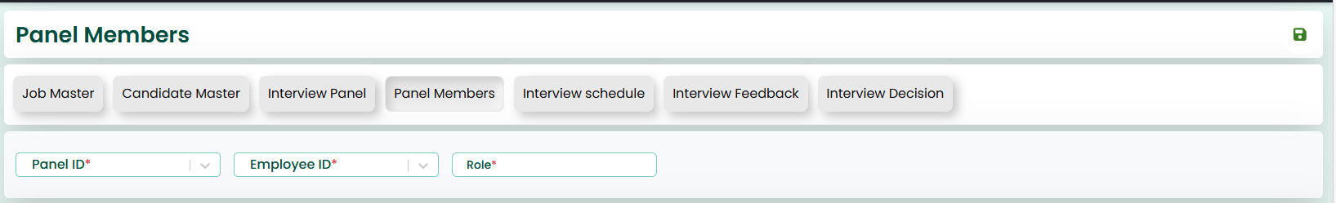
Action Button:
✧ This screen also features 'Save' and 'Reload' buttons located at the top-right corner.
✧ On this screen, the user must enter all the required member details. After entering the data, by clicking the 'Save' button, the panel member details will be saved in the system.
✧ All mandatory fields are marked with (*). The user must fill these fields before saving the data.
Search Criteria
✧ This screen provides a Search Criteria section to retrieve existing panel member records.
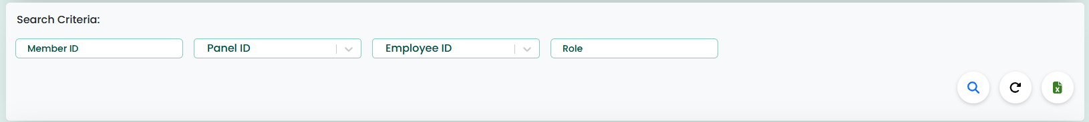
✧ The user can search the panel member data using the following fields:
Member ID
Panel ID
Employee ID
Role
✧ After entering the search criteria, clicking the Search icon will display the matching panel member records.
Action Button
✧ The Reload icon clears all search fields and reloads the data.
✧ The Excel icon is used to export the displayed panel member records into an Excel file.
Data Grid
✧ The saved panel member records are displayed in the grid below the search section.
✧ The grid shows details such as Member ID, Panel ID, Employee ID, and Role.
✧ When the user selects a record from the grid, the data will be loaded into the screen.
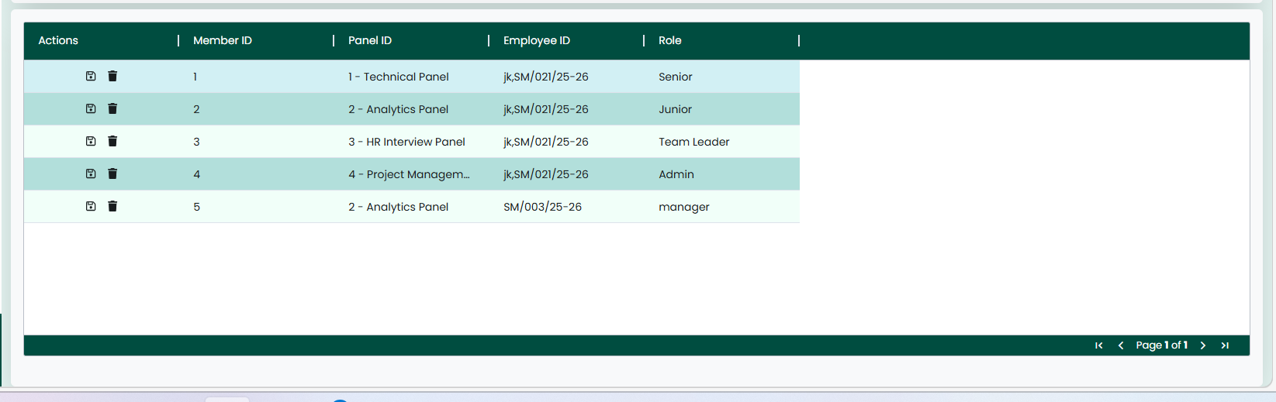
Action Button:
✧ Once the data is fetched, if the user wants to update or delete it, "Update" and "Delete" buttons will appear on the right side. These allow the user to modify or delete the data as needed.
✧ The 'Reload' button can be used to refresh the page, clearing all fields and resetting the screen to its initial state.
Interview Schedule:
✧ The Interview Schedule screen enables users to create, manage, and maintain interview scheduling details within the system. It is used to plan and organize interviews by assigning candidates to panels along with date, time, and mode of interview.
Selecting the “Interview Schedule” tab from the main navigation bar directs the user to the Interview Schedule screen.
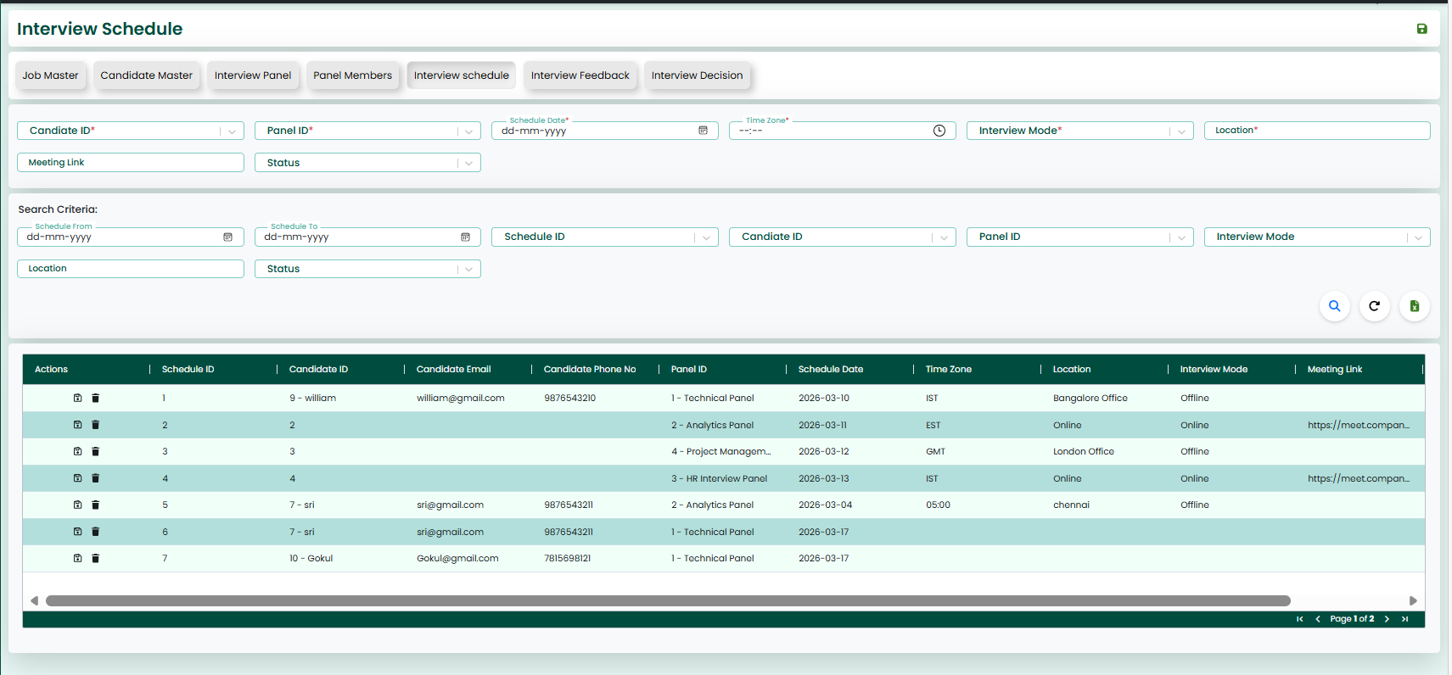
✧ The image shown above illustrates the Interview Schedule screen.
✧ This screen is used to enter and manage interview schedule details such as Candidate ID, Panel ID, Schedule Date, Time Zone, Interview Mode, Location, Meeting Link, and Status.
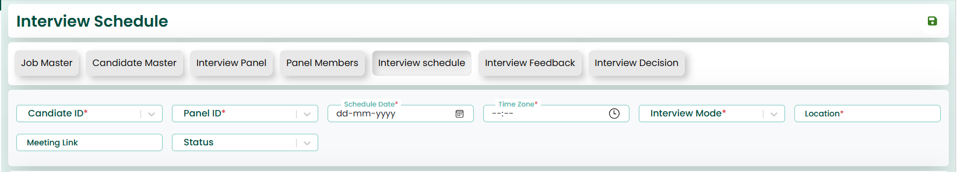
Action Button:
✧ This screen also features 'Save' and 'Reload' buttons located at the top-right corner.
✧ On this screen, the user must enter all the required scheduling details. After entering the data, by clicking the 'Save' button, the interview schedule will be saved in the system.
✧ All mandatory fields are marked with (*). The user must fill these fields before saving the data.
Search Criteria
✧ This screen provides a Search Criteria section to retrieve existing interview schedules.
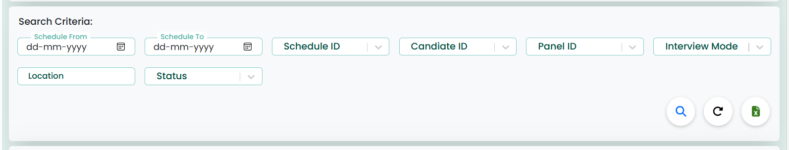
✧ The user can search the schedule data using the following fields:
Schedule From
Schedule To
Schedule ID
Candidate ID
Panel ID
Interview Mode
Location
Status
✧ After entering the search criteria, clicking the Search icon will display the matching interview schedule records.
Action Button
✧ The Reload icon clears all search fields and reloads the data.
✧ The Excel icon is used to export the displayed interview schedule records into an Excel file.
Data Grid
✧ The saved interview schedules are displayed in the grid below the search section.
✧ The grid shows details such as Schedule ID, Candidate ID, Panel ID, Schedule Date, Time Zone, Interview Mode, Location, and Status.
✧ When the user selects a record from the grid, the data will be loaded into the screen.
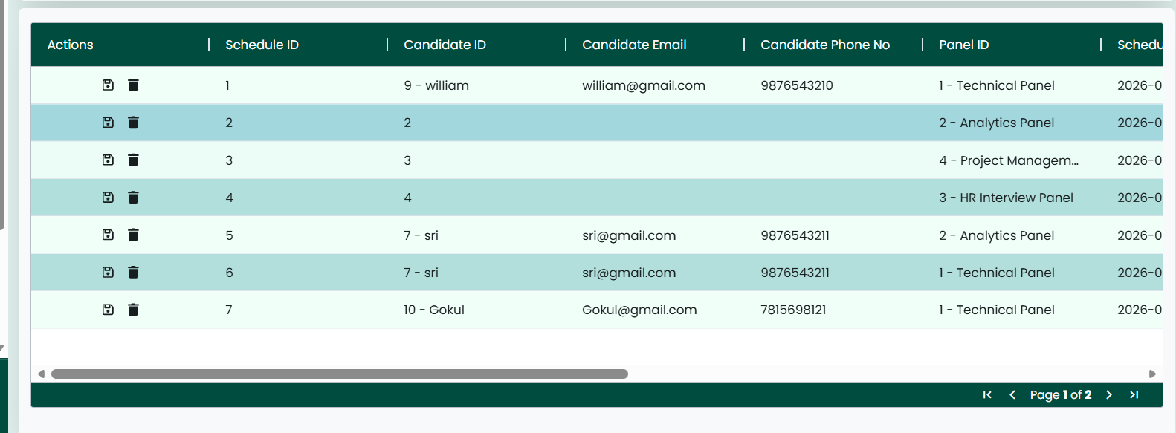

Action Button:
✧ Once the data is fetched, if the user wants to update or delete it, "Update" and "Delete" buttons will appear on the right side. These allow the user to modify or delete the data as needed.
✧ The 'Reload' button can be used to refresh the page, clearing all fields and resetting the screen to its initial state.

Interview Feedback:
✧ The Interview Feedback screen enables users to create, manage, and maintain feedback details for conducted interviews within the system. It is used to record interviewer evaluations, ratings, and recommendations for candidates.
Selecting the “Interview Feedback” tab from the main navigation bar directs the user to the Interview Feedback screen.
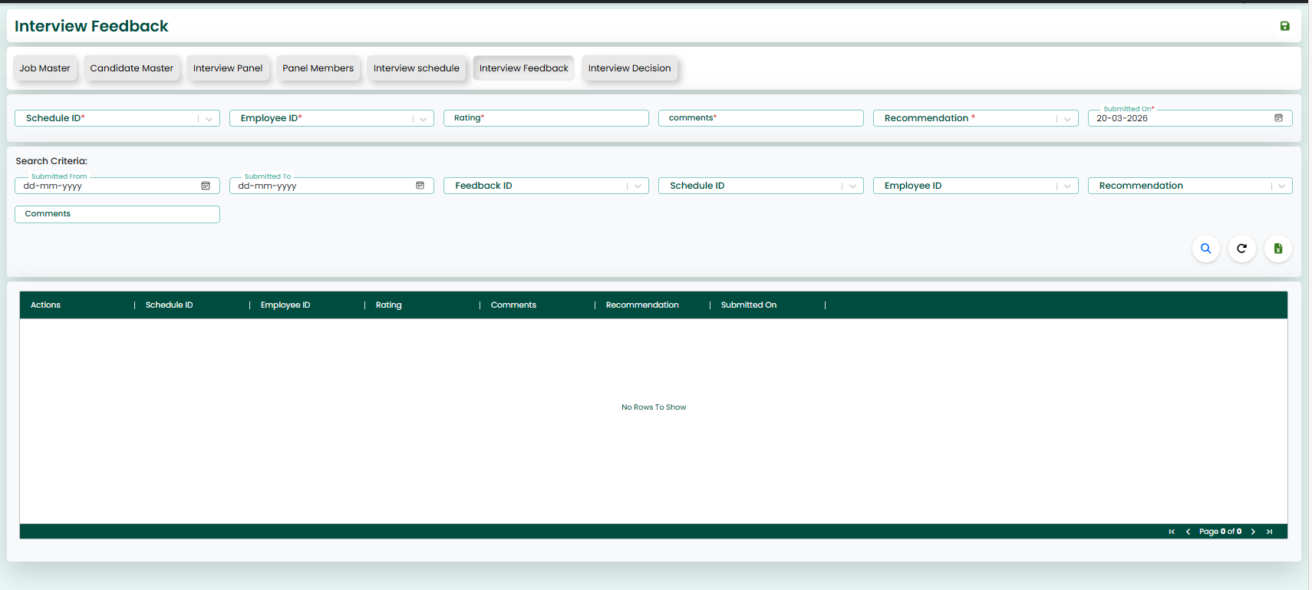
✧ The image shown above illustrates the Interview Feedback screen.
✧ This screen is used to enter and manage feedback details such as Schedule ID, Employee ID, Rating, Comments, Recommendation, and Submitted On.
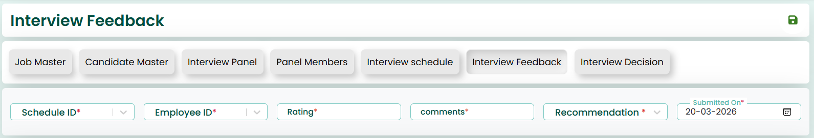
Action Button:
✧ This screen also features 'Save' and 'Reload' buttons located at the top-right corner.
✧ On this screen, the user must enter all the required feedback details. After entering the data, by clicking the 'Save' button, the interview feedback will be saved in the system.
✧ All mandatory fields are marked with (*). The user must fill these fields before saving the data.
Search Criteria
✧ This screen provides a Search Criteria section to retrieve existing feedback records.
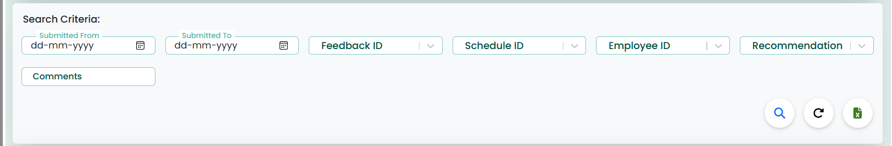
✧ The user can search the feedback data using the following fields:
Submitted From
Submitted To
Feedback ID
Schedule ID
Employee ID
Recommendation
Comments
✧ After entering the search criteria, clicking the Search icon will display the matching feedback records.
Action Button
✧ The Reload icon clears all search fields and reloads the data.
✧ The Excel icon is used to export the displayed feedback records into an Excel file.

Data Grid
✧ The saved feedback records are displayed in the grid below the search section.
✧ The grid shows details such as Feedback ID, Schedule ID, Employee ID, Rating, Recommendation, Comments, and Submitted On.
✧ When the user selects a record from the grid, the data will be loaded into the screen.
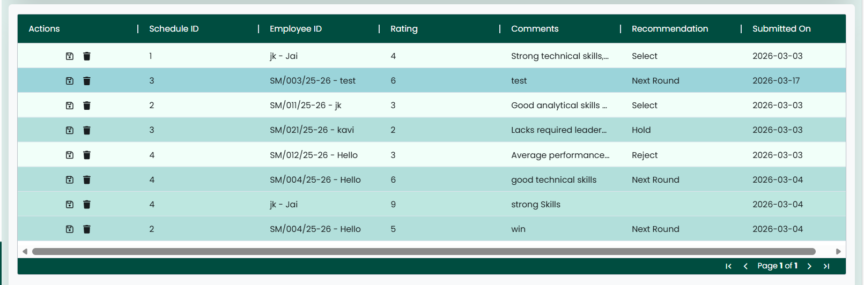
Action Button:
✧ Once the data is fetched, if the user wants to update or delete it, "Update" and "Delete" buttons will appear on the right side. These allow the user to modify or delete the data as needed.
✧ The 'Reload' button can be used to refresh the page, clearing all fields and resetting the screen to its initial state.

Interview Decision:
✧ The Interview Decision screen enables users to create, manage, and maintain final decision details for candidates within the recruitment process. It is used to record the outcome of interviews and finalize the candidate’s status.
Selecting the “Interview Decision” tab from the main navigation bar directs the user to the Interview Decision screen.
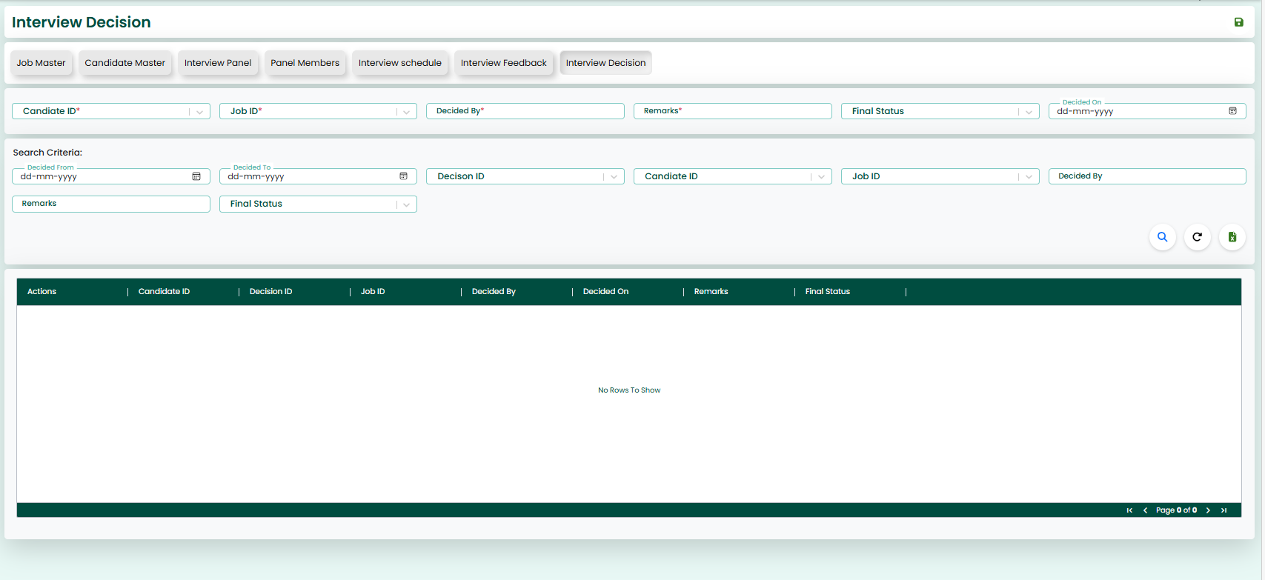
✧ The image shown above illustrates the Interview Decision screen.
✧ This screen is used to enter and manage decision-related details such as Candidate ID, Job ID, Decided By, Remarks, Final Status, and Decided On.
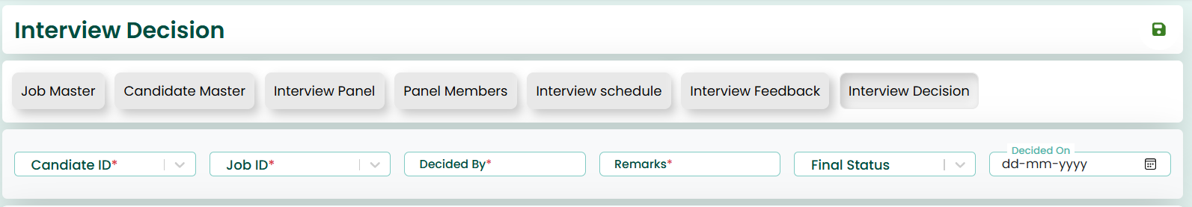
Action Button:
✧ This screen also features 'Save' and 'Reload' buttons located at the top-right corner.
✧ On this screen, the user must enter all the required decision details. After entering the data, by clicking the 'Save' button, the interview decision will be saved in the system.
✧ All mandatory fields are marked with (*). The user must fill these fields before saving the data.
Search Criteria
✧ This screen provides a Search Criteria section to retrieve existing decision records.
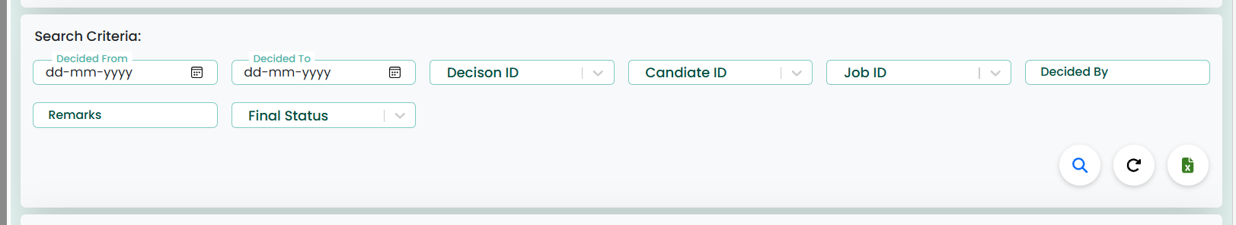
✧ The user can search the decision data using the following fields:
Decided From
Decided To
Decision ID
Candidate ID
Job ID
Decided By
Remarks
Final Status
✧ After entering the search criteria, clicking the Search icon will display the matching decision records.
Action Button
✧ The Reload icon clears all search fields and reloads the data.
✧ The Excel icon is used to export the displayed decision records into an Excel file.
Data Grid
✧ The saved decision records are displayed in the grid below the search section.
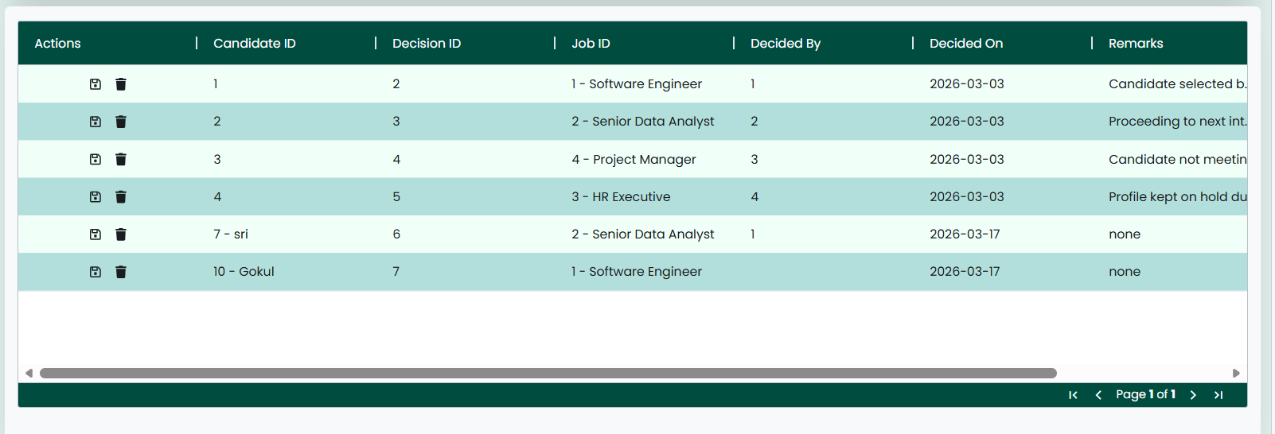
✧ The grid shows details such as Decision ID, Candidate ID, Job ID, Decided By, Remarks, Final Status, and Decided On.
✧ When the user selects a record from the grid, the data will be loaded into the screen.

Action Button:
✧ Once the data is fetched, if the user wants to update or delete it, "Update" and "Delete" buttons will appear on the right side. These allow the user to modify or delete the data as needed.
✧ The 'Reload' button can be used to refresh the page, clearing all fields and resetting the screen to its initial state.

C H A P T E R

Interview Dashboard
1. Overview
The Interview Dashboard provides a quick and clear summary of the recruitment process. It helps users monitor candidate progress, track selections, and analyze interview distribution across panels and departments within a selected date range.
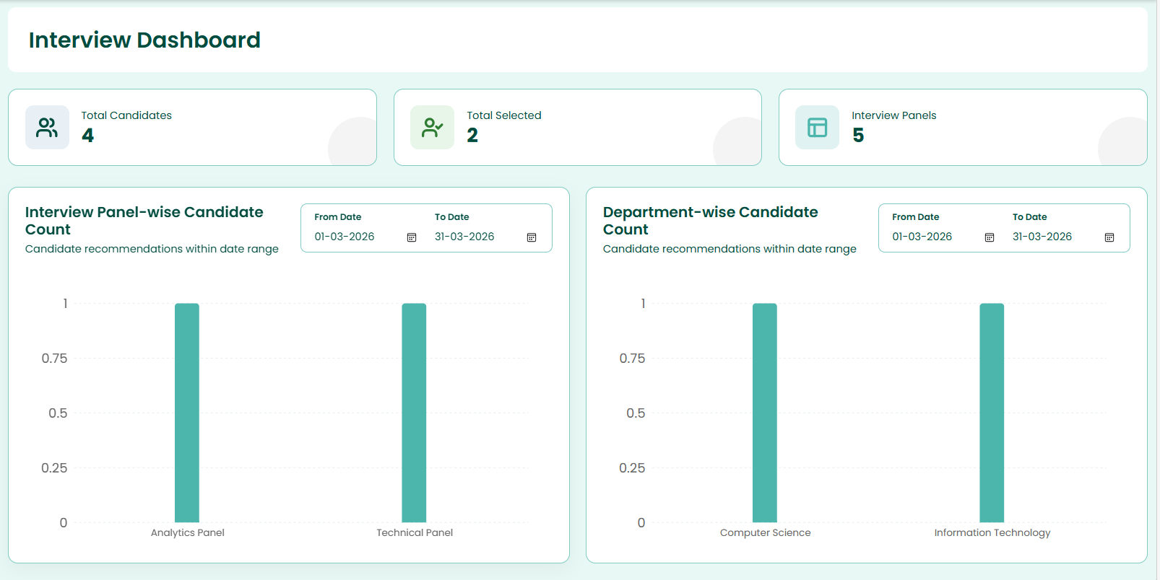
2. Dashboard Summary
At the top of the dashboard, three key metrics are displayed:
- Total Candidates:
Shows the total number of candidates available in the system.
(Example: 4 candidates)
- Total Selected:
Displays the number of candidates who have been successfully selected.
(Example: 2 candidates)
- Interview Panels:
Indicates the number of interview panels involved in the hiring process.
(Example: 5 panels)
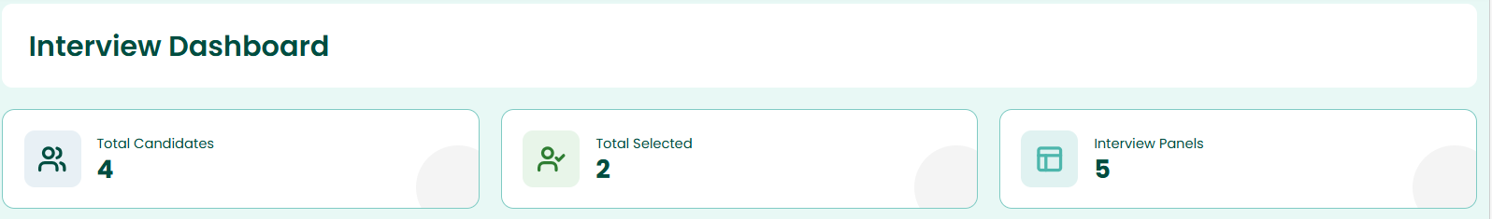
3. Interview Panel-wise Candidate Count
This section presents a bar chart showing how many candidates are assigned to each interview panel.
Features:
- Date filter options:
  - From Date
  - To Date
- Visual comparison of candidate distribution across panels.
- Helps identify workload per panel.
Example Panels:
- Analytics Panel
- Technical Panel
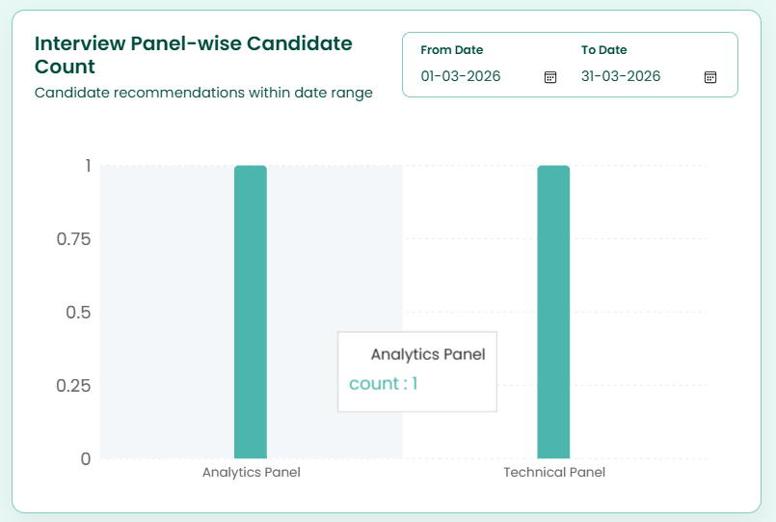
4. Department-wise Candidate Count
This section displays a bar chart representing candidate distribution across different departments.
Features:
- Date filter options:
  - From Date
  - To Date
- Helps analyze hiring trends across departments.
- Useful for understanding department-wise recruitment demand.
Example Departments:
- Computer Science
- Information Technology
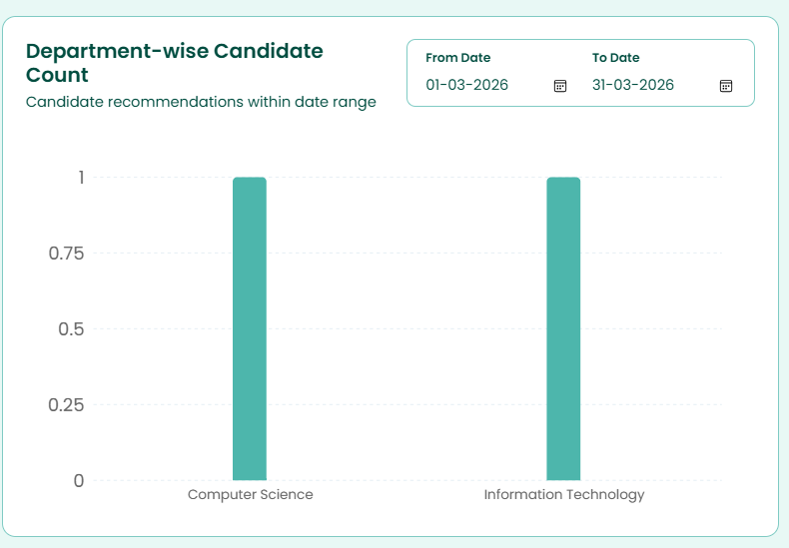
5. Date Range Filters
Both chart sections include date filters that allow users to refine the data displayed.
Purpose:
- View candidate data for a specific time period.
- Analyze recruitment trends over selected dates.
Fields:
- From Date: Start of the date range
- To Date: End of the date range
(Example: 01-03-2026 to 31-03-2026)

6. Benefits of the Dashboard
- Provides a quick summary of recruitment status
- Helps in decision-making
- Tracks candidate progress efficiently
- Offers visual insights through charts

C H A P T E R

Interview Schedule Report
✧ The Interview Schedule Report screen enables users to view, search, and manage interview schedules within the recruitment process. It helps track scheduled interviews and monitor candidate interview details.
✧ Selecting the “Interview Schedule Report” tab from the main navigation bar directs the user to the Interview Schedule Report screen.
✧ The image shown above illustrates the Interview Schedule Report screen.
✧ This screen is used to view and manage schedule-related details such as Schedule ID, Candidate Name, Email, Panel Name, Interview Mode, Location, and Schedule Date.
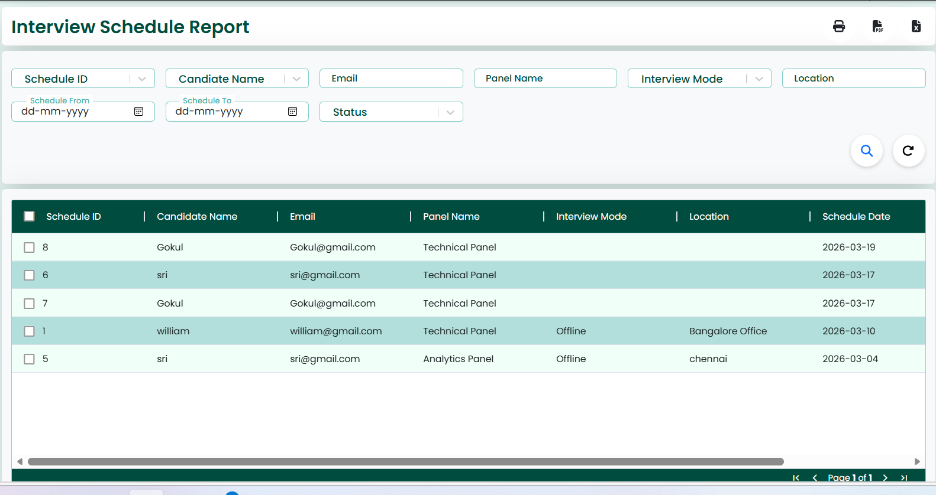
Action Button:
✧ This screen also features Print, PDF, and Excel icons located at the top-right corner.
✧ The Print icon is used to print the report.
✧ The PDF icon allows the user to download the report in PDF format.
✧ The Excel icon is used to export the report data into an Excel file.
Search Criteria
✧ This screen provides a Search Criteria section to retrieve interview schedule records.
✧ The user can search the schedule data using the following fields:
- Schedule ID
- Candidate Name
- Email
- Panel Name
- Interview Mode
- Location
- Schedule From
- Schedule To
- Status
✧ After entering the search criteria, clicking the Search icon will display the matching schedule records.
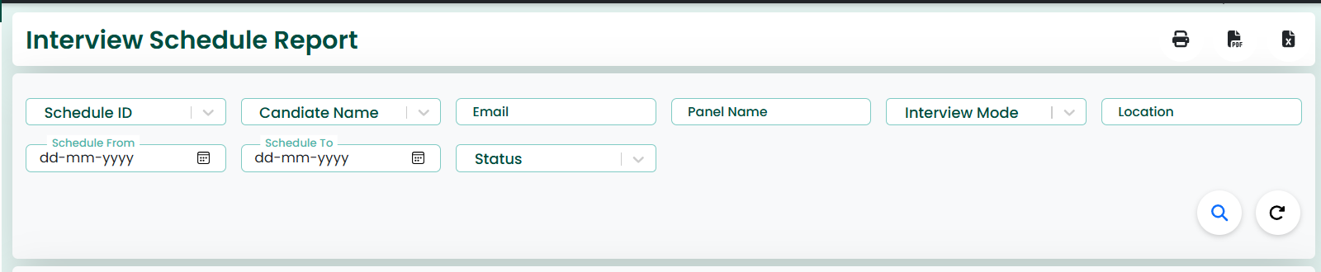
Action Button
✧ The Reload icon clears all search fields and reloads the data.
✧ The Search icon is used to fetch filtered schedule records.

Data Grid
✧ The scheduled interview records are displayed in the grid below the search section.
✧ The grid shows details such as Schedule ID, Candidate Name, Email, Panel Name, Interview Mode, Location, and Schedule Date.
✧ Each record includes a checkbox for selection.
✧ The grid provides a clear and structured view of all interview schedules.
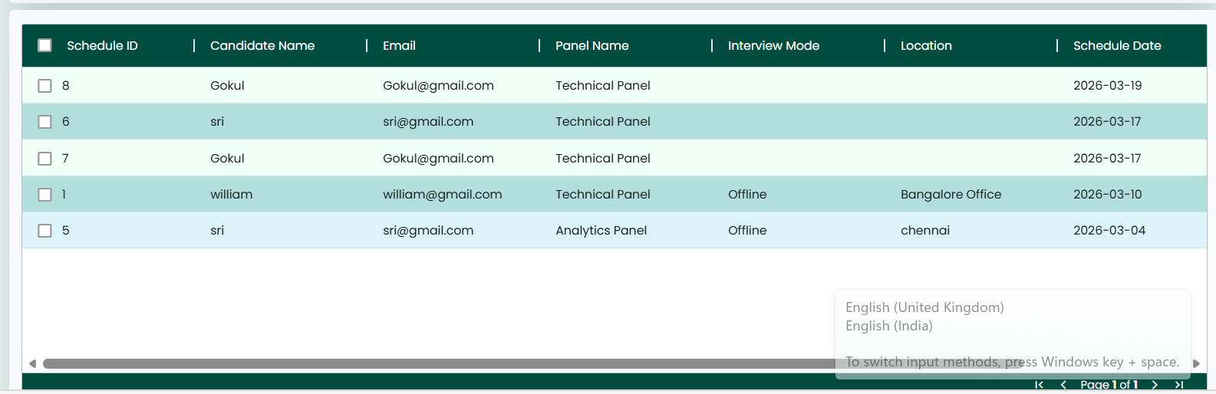
Action Button:
✧ The Reload button/icon can be used to refresh the page, clearing all fields and resetting the screen to its initial state.

C H A P T E R

Interview Feedback Report
Interview Feedback Report
✧ The Interview Feedback Report screen enables users to view, search, and analyze feedback provided by interviewers for candidates during the recruitment process.
✧ Selecting the “Interview Feedback Report” tab from the main navigation bar directs the user to the Interview Feedback Report screen.
✧ The image shown above illustrates the Interview Feedback Report screen.
✧ This screen is used to manage and review feedback details such as Schedule ID, Interviewer ID, Candidate Name, Submitted On, Recommendation, Comments, and Role.
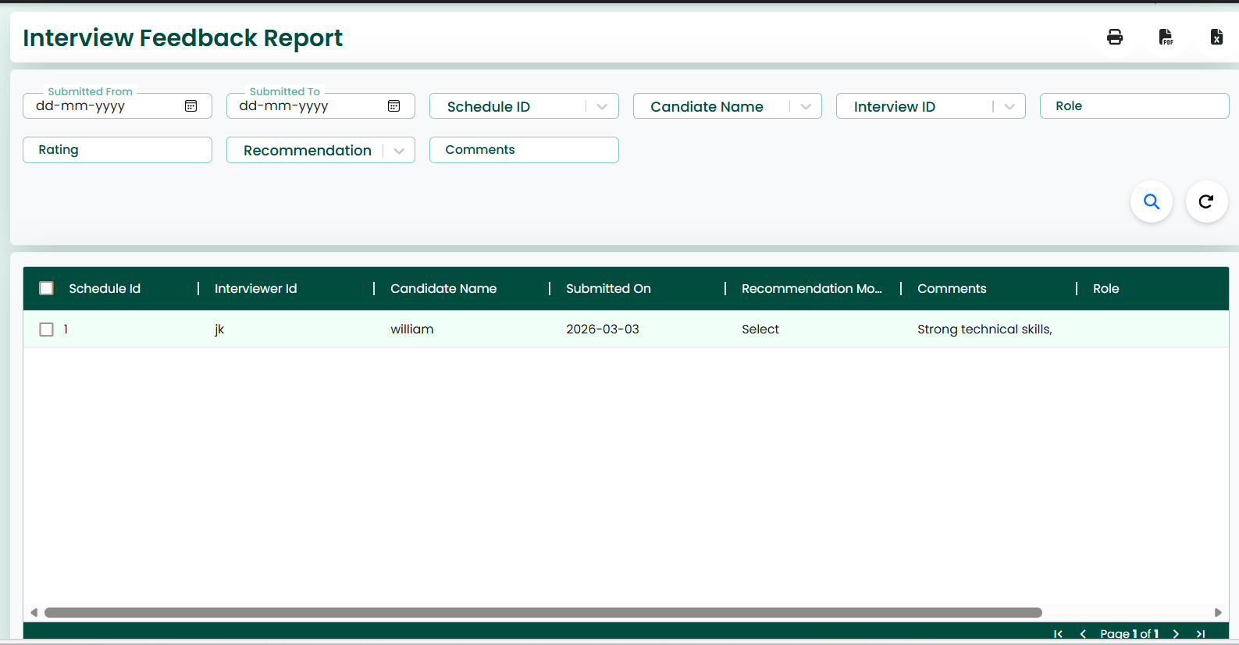
Action Button:
✧ This screen also features Print, PDF, and Excel icons located at the top-right corner.
✧ The Print icon is used to print the feedback report.✧ The PDF icon allows the user to download the report in PDF format.✧ The Excel icon is used to export the report data into an Excel file.
Search Criteria
✧ This screen provides a Search Criteria section to retrieve interview feedback records.
✧ The user can search the feedback data using the following fields:
- Submitted From
- Submitted To
- Schedule ID
- Candidate Name
- Interview ID
- Role
- Rating
- Recommendation
- Comments
✧ After entering the search criteria, clicking the Search icon will display the matching feedback records.
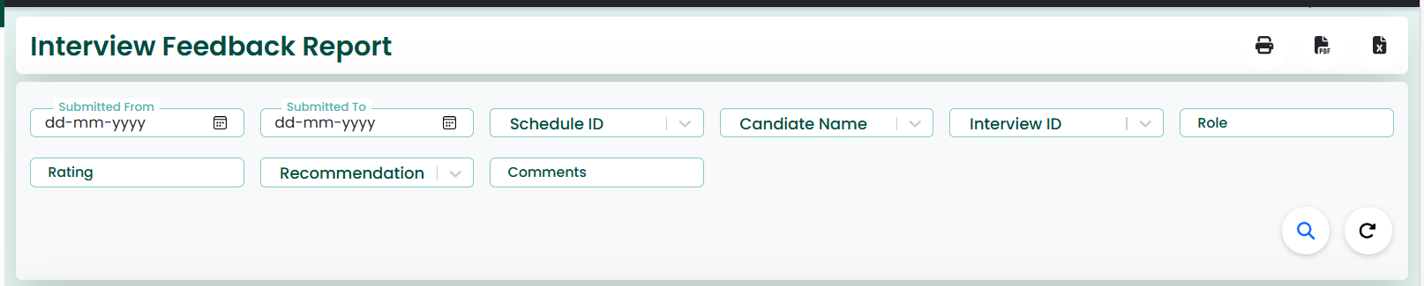
Action Button
✧ The Search icon is used to fetch filtered feedback records.
✧ The Reload icon clears all search fields and reloads the data.
Data Grid
✧ The interview feedback records are displayed in the grid below the search section.
✧ The grid shows details such as Schedule ID, Interviewer ID, Candidate Name, Submitted On, Recommendation, Comments, and Role.
✧ Each record includes a checkbox for selection.
✧ The grid provides a structured and easy-to-read view of feedback data.

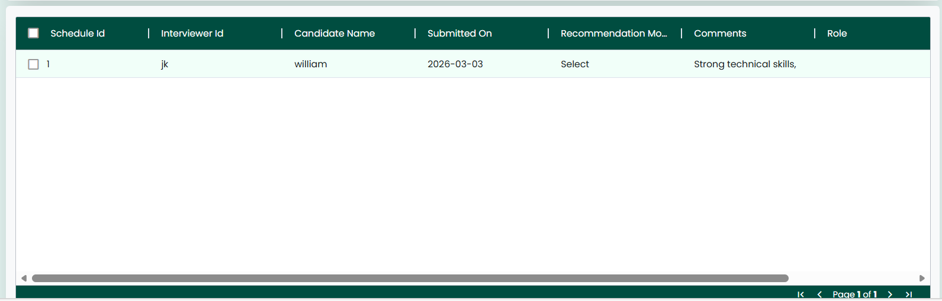
Action Button:
✧ The Reload button/icon can be used to refresh the page, clearing all fields and resetting the screen to its initial state.

C H A P T E R

Candidate Interview Report
Candidate Interview Report
✧ The Candidate Interview Report screen enables users to view, search, and analyze interview details and final decisions for candidates during the recruitment process.
✧ Selecting the “Candidate Interview Report” tab from the main navigation bar directs the user to the Candidate Interview Report screen.
✧ The image shown above illustrates the Candidate Interview Report screen.
✧ This screen is used to manage and review candidate interview details such as Schedule Date, Decision Date, Candidate Name, Rating, Final Status, and Remarks.
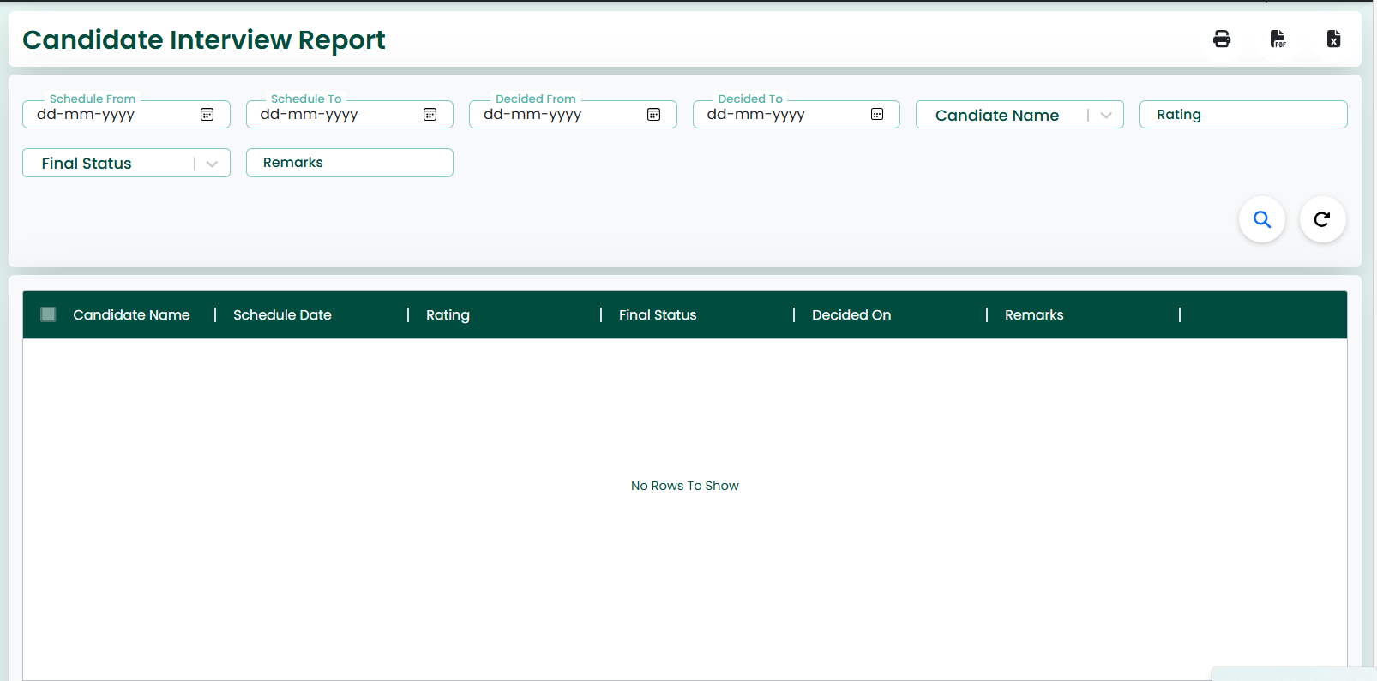
Action Button:
✧ This screen also features Print, PDF, and Excel icons located at the top-right corner.
✧ The Print icon is used to print the candidate interview report.
✧ The PDF icon allows the user to download the report in PDF format.
✧ The Excel icon is used to export the report data into an Excel file.

Search Criteria
✧ This screen provides a Search Criteria section to retrieve candidate interview records.
✧ The user can search the interview data using the following fields:
- Schedule From
- Schedule To
- Decided From
- Decided To
- Candidate Name
- Rating
- Final Status
- Remarks
✧ After entering the search criteria, clicking the Search icon will display the matching interview records.
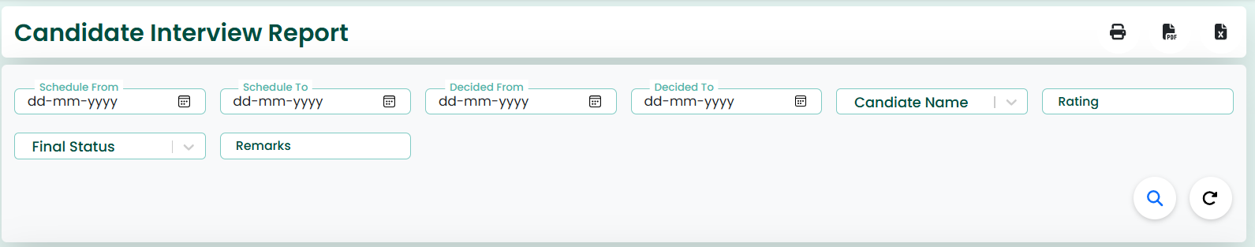
Action Button
✧ The Search icon is used to fetch filtered interview records.
✧ The Reload icon clears all search fields and reloads the data.
Data Grid
✧ The candidate interview records are displayed in the grid below the search section.
✧ The grid shows details such as Candidate Name, Schedule Date, Decision Date, Rating, Final Status, and Remarks.
✧ Each record includes a checkbox for selection.
✧ The grid provides a structured and easy-to-read view of interview data.
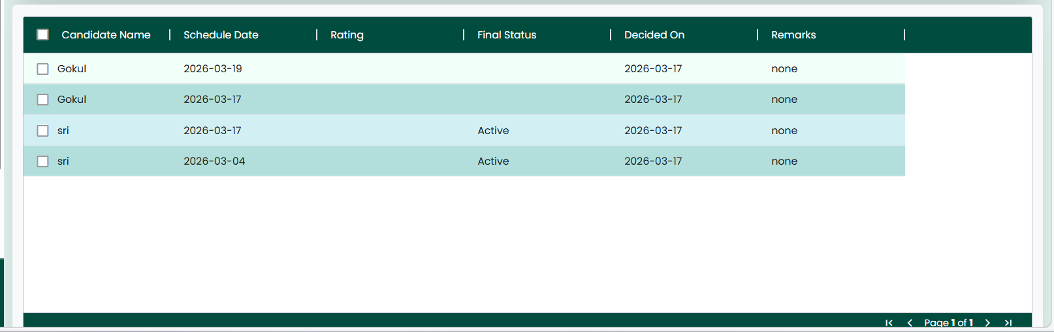
Action Button:
✧ The Reload button/icon can be used to refresh the page, clearing all fields and resetting the screen to its initial state.

C H A P T E R

Panel Performance Report
✧ The Panel Performance Report screen enables users to view, search, and analyze the performance of interview panels based on candidate feedback and ratings.
✧ Selecting the “Panel Performance Report” tab from the main navigation bar directs the user to the Panel Performance Report screen.
✧ The image shown above illustrates the Panel Performance Report screen.
✧ This screen is used to review panel-related details such as Panel Name, Average Rating, Total Interviews, and submission timelines.
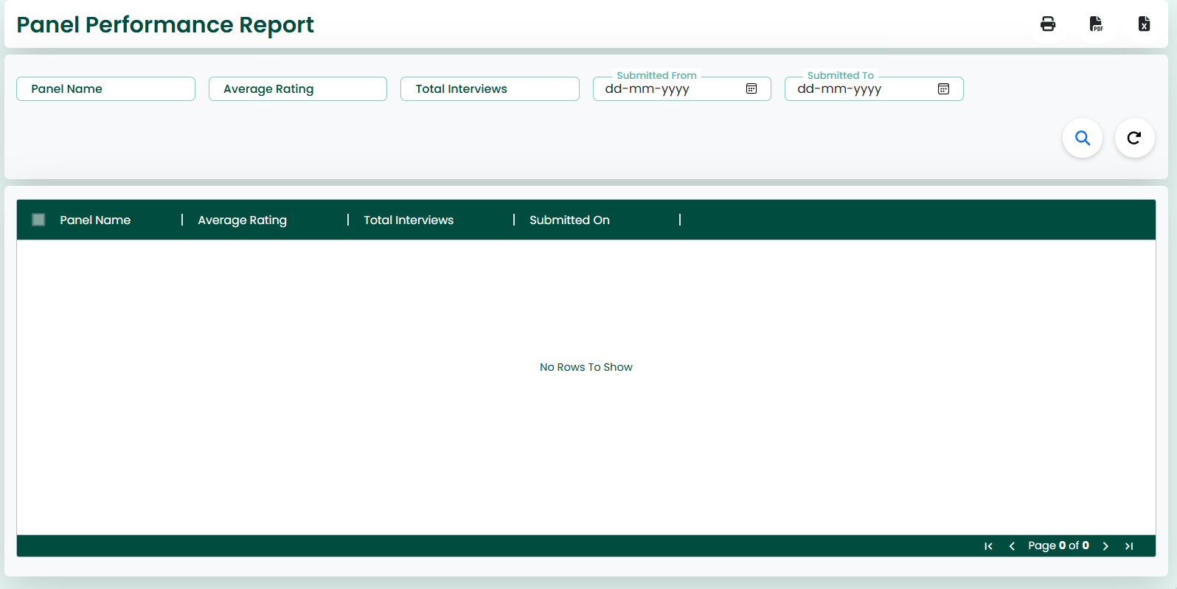
Action Button:
✧ This screen also features Print, PDF, and Excel icons located at the top-right corner.
✧ The Print icon is used to print the panel performance report.
✧ The PDF icon allows the user to download the report in PDF format.
✧ The Excel icon is used to export the report data into an Excel file.
Search Criteria
✧ This screen provides a Search Criteria section to retrieve panel performance records.
✧ The user can search the data using the following fields:
- Panel Name
- Average Rating
- Total Interviews
- Submitted From
- Submitted To
✧ After entering the search criteria, clicking the Search icon will display the matching panel performance records.
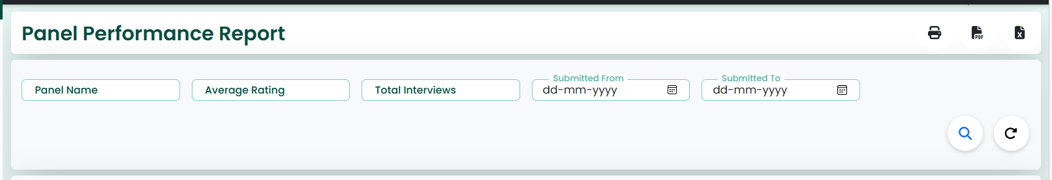
Action Button
✧ The Search icon is used to fetch filtered panel performance records.
✧ The Reload icon clears all search fields and reloads the data.
Data Grid
✧ The panel performance records are displayed in the grid below the search section.
✧ The grid shows details such as Panel Name, Average Rating, Total Interviews, Submitted From, and Submitted To.
✧ Each record includes a checkbox for selection.
✧ The grid provides a structured and easy-to-read view of panel performance data.
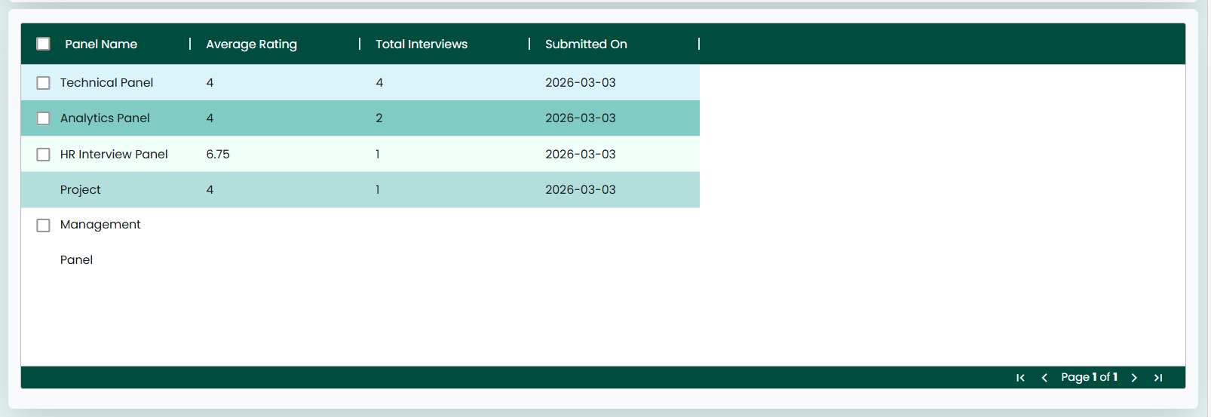
Action Button:✧ The Reload button/icon can be used to refresh the page, clearing all fields and resetting the screen to its initial state.

C H A P T E R

Hiring Decision Report
✧ The Hiring Decision Report screen enables users to view, search, and analyze final hiring decisions made for candidates during the recruitment process.
✧ Selecting the “Hiring Decision Report” tab from the main navigation bar directs the user to the Hiring Decision Report screen.
✧ The image shown above illustrates the Hiring Decision Report screen.
✧ This screen is used to manage and review hiring decision details such as Candidate Name, Job Title, Department ID, Country Code, Final Status, and Decided By.
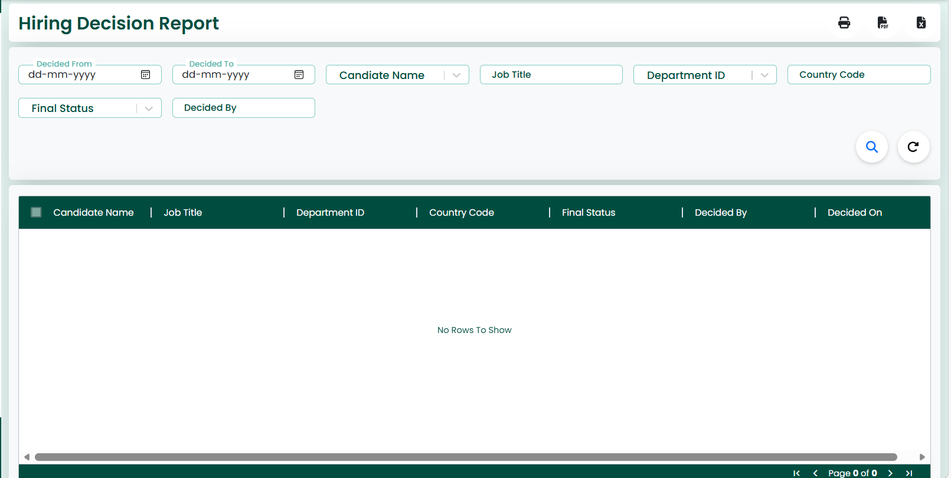
Action Button:
✧ This screen also features Print, PDF, and Excel icons located at the top-right corner.
✧ The Print icon is used to print the hiring decision report.
✧ The PDF icon allows the user to download the report in PDF format.
✧ The Excel icon is used to export the report data into an Excel file.
Search Criteria
✧ This screen provides a Search Criteria section to retrieve hiring decision records.
✧ The user can search the data using the following fields:
- Decided From
- Decided To
- Candidate Name
- Job Title
- Department ID
- Country Code
- Final Status
- Decided By
✧ After entering the search criteria, clicking the Search icon will display the matching hiring decision records.
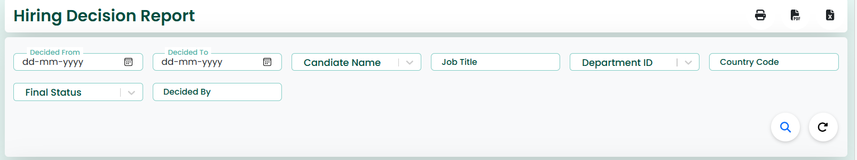
Action Button
✧ The Search icon is used to fetch filtered hiring decision records.
✧ The Reload icon clears all search fields and reloads the data.
Data Grid
✧ The hiring decision records are displayed in the grid below the search section.
✧ The grid shows details such as Candidate Name, Job Title, Department ID, Country Code, Final Status, Decided By, and Decision Date.
✧ Each record includes a checkbox for selection.
✧ The grid provides a structured and easy-to-read view of hiring decision data.
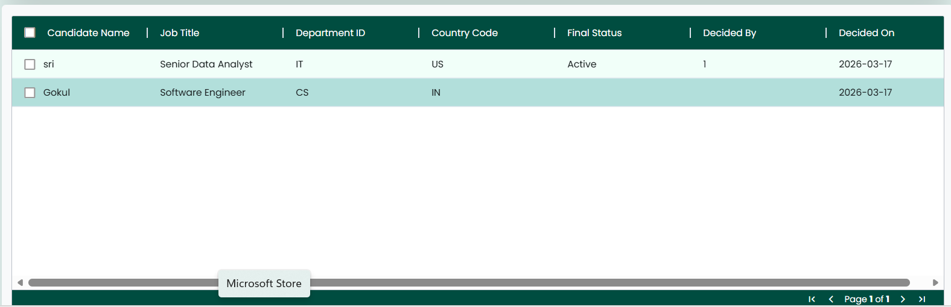

Action Button:
✧ The Reload button/icon can be used to refresh the page, clearing all fields and resetting the screen to its initial state.

C H A P T E R

Total Candidate Applied

✧ The Total Candidates Applied screen enables users to view, search, and analyze details of all candidates who have applied for job openings in the recruitment system.
✧ Selecting the “Total Candidates Applied” tab from the main navigation bar directs the user to this screen.
✧ The image shown above illustrates the Total Candidates Applied screen.
✧ This screen is used to manage and review candidate application details such as Candidate Name, Email, Phone, Applied Job ID, Education, Experience, Related Experience, and Job Description.
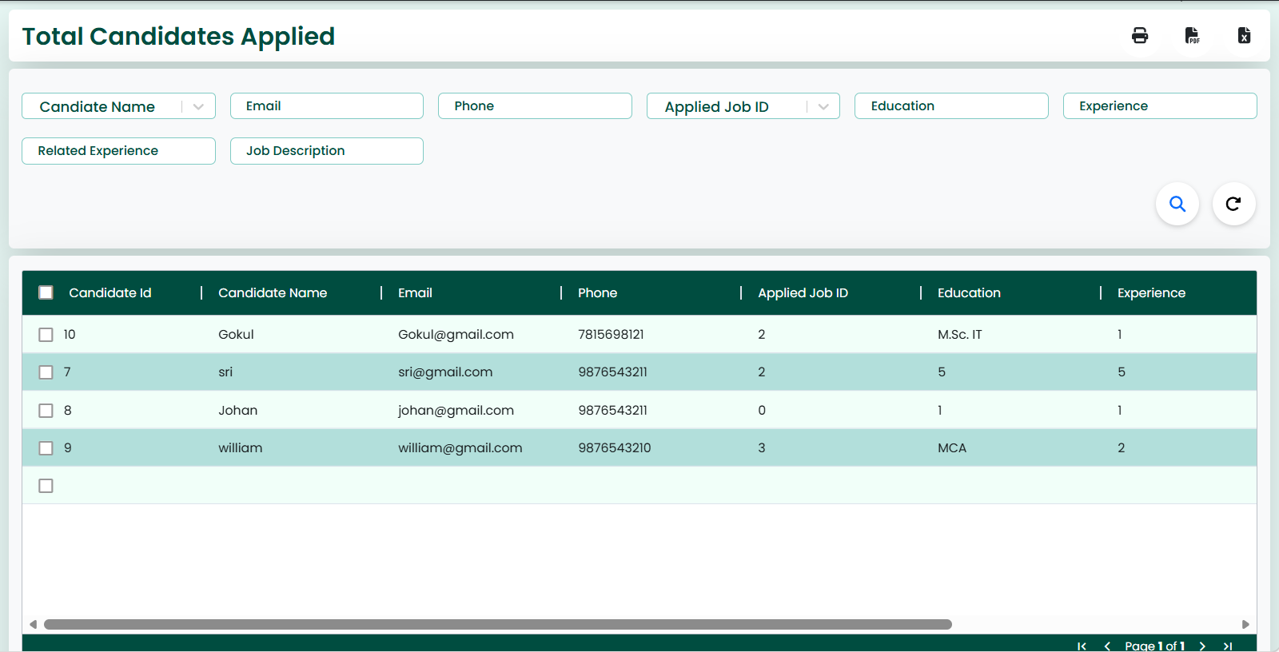

Action Button:
✧ This screen also features Print, PDF, and Excel icons located at the top-right corner.
✧ The Print icon is used to print the candidates applied report.
✧ The PDF icon allows the user to download the report in PDF format.
✧ The Excel icon is used to export the report data into an Excel file.

Search Criteria
✧ This screen provides a Search Criteria section to retrieve candidate application records.
✧ The user can search the data using the following fields:
- Candidate Name
- Email
- Phone
- Applied Job ID
- Education
- Experience
- Related Experience
- Job Description
✧ After entering the search criteria, clicking the Search icon will display the matching candidate records.
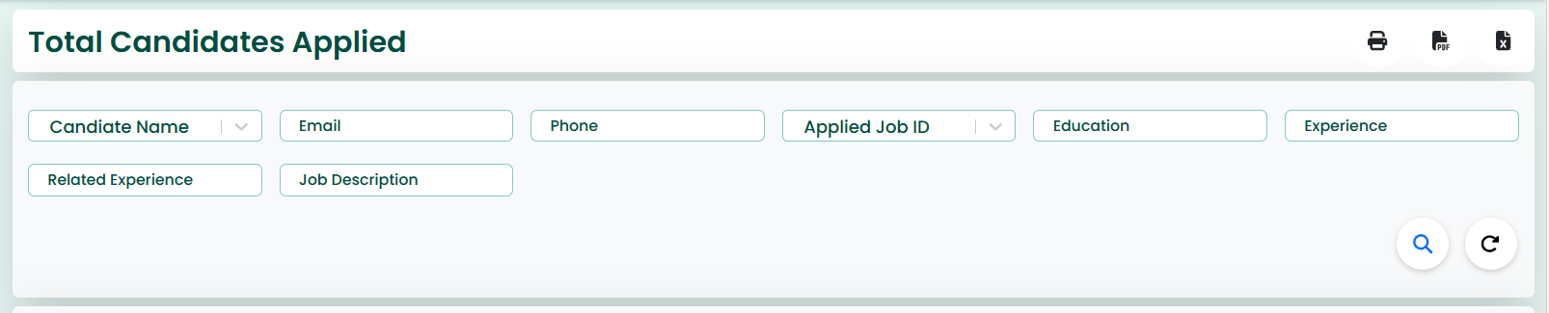
Action Button
✧ The Search icon is used to fetch filtered candidate records.
✧ The Reload icon clears all search fields and reloads the data.

Data Grid
✧ The candidate application records are displayed in the grid below the search section.
✧ The grid shows details such as Candidate Name, Email, Phone, Applied Job ID, Education, Experience, Related Experience, and Job Description.
✧ Each record includes a checkbox for selection.
✧ The grid provides a structured and easy-to-read view of candidate application data.
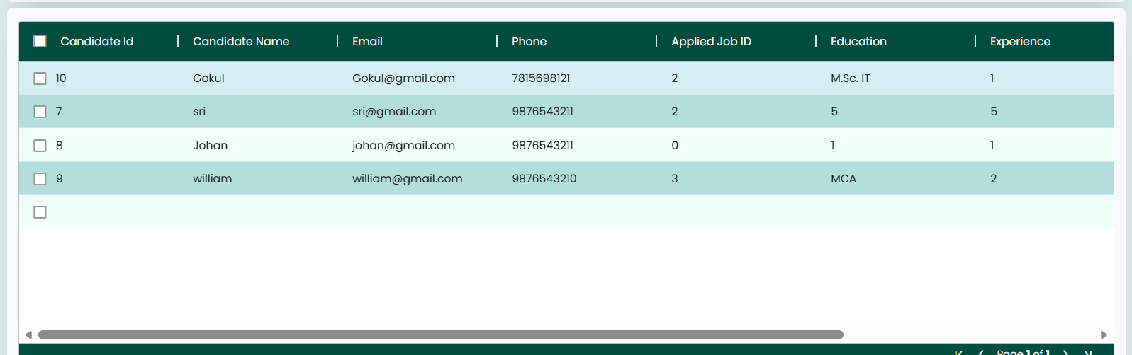
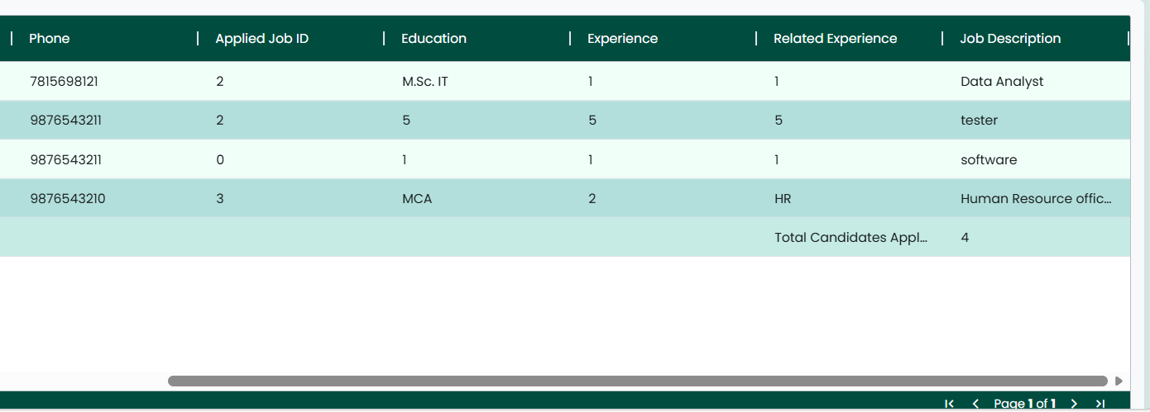
Action Button:
✧ The Reload button/icon can be used to refresh the page, clearing all fields and resetting the screen to its initial state.

C H A P T E R

Total Interview Schedule

✧ The Total Interviews Schedule screen enables users to view, search, and analyse all scheduled interviews within the recruitment process.
✧ Selecting the “Total Interviews Schedule” tab from the main navigation bar directs the user to this screen.
✧ The image shown above illustrates the Total Interviews Schedule screen.
✧ This screen is used to manage and review interview scheduling details such as Schedule ID, Candidate ID, Panel ID, Interview Mode, Location, Status, Meeting Link, and Time Zone.
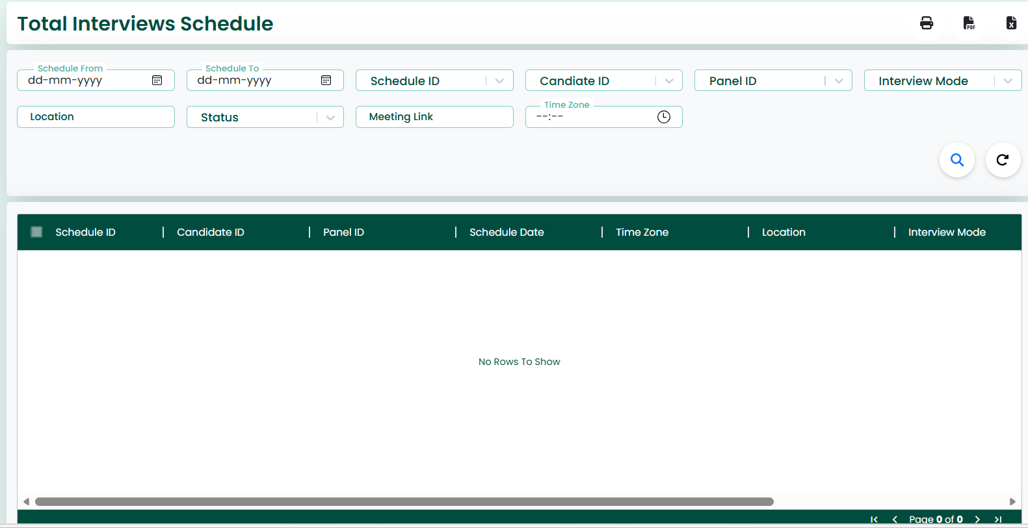
Action Button:
✧ This screen also features Print, PDF, and Excel icons located at the top-right corner.
✧ The Print icon is used to print the interview schedule report.
✧ The PDF icon allows the user to download the report in PDF format.
✧ The Excel icon is used to export the report data into an Excel file.
Search Criteria
✧ This screen provides a Search Criteria section to retrieve interview schedule records.
✧ The user can search the data using the following fields:
- Schedule From
- Schedule To
- Schedule ID
- Candidate ID
- Panel ID
- Interview Mode
- Location
- Status
- Meeting Link
- Time Zone
✧ After entering the search criteria, clicking the Search icon will display the matching interview schedule records.
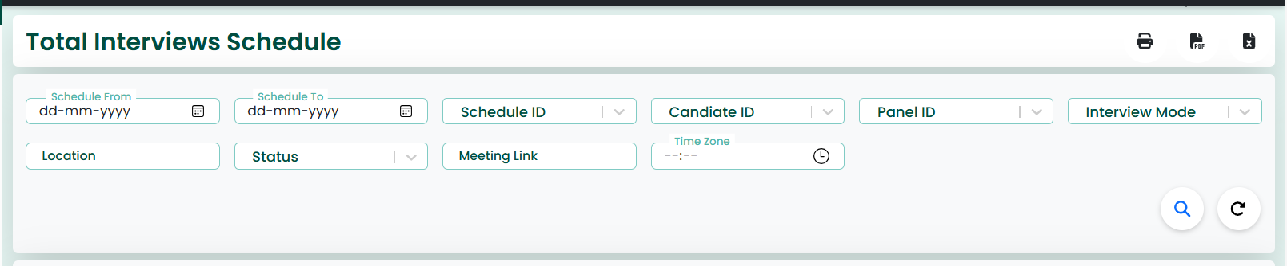
Action Button
✧ The Search icon is used to fetch filtered interview schedule records.
✧ The Reload icon clears all search fields and reloads the data.
Data Grid
✧ The interview schedule records are displayed in the grid below the search section.
✧ The grid shows details such as Schedule ID, Candidate ID, Panel ID, Interview Mode, Location, Status, Meeting Link, Time Zone, and Schedule Date.
✧ Each record includes a checkbox for selection.
✧ The grid provides a structured and easy-to-read view of interview scheduling data.
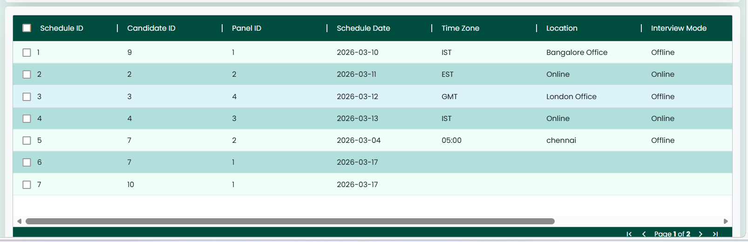
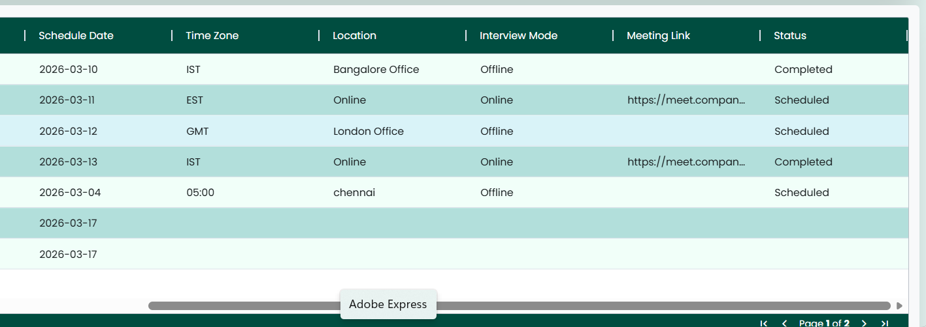
Action Button:
✧ The Reload button/icon can be used to refresh the page, clearing all fields and resetting the screen to its initial state.

C H A P T E R

Interview Completion Rate
✧ The Interview Completion Rate screen enables users to view, search, and analyze the completion status of interviews based on submitted feedback.
✧ Selecting the “Interview Completion Rate” tab from the main navigation bar directs the user to this screen.
✧ The image shown above illustrates the Interview Completion Rate screen.
✧ This screen is used to monitor and review interview completion details such as Feedback ID, Schedule ID, Employee ID, Recommendation, and Comments.
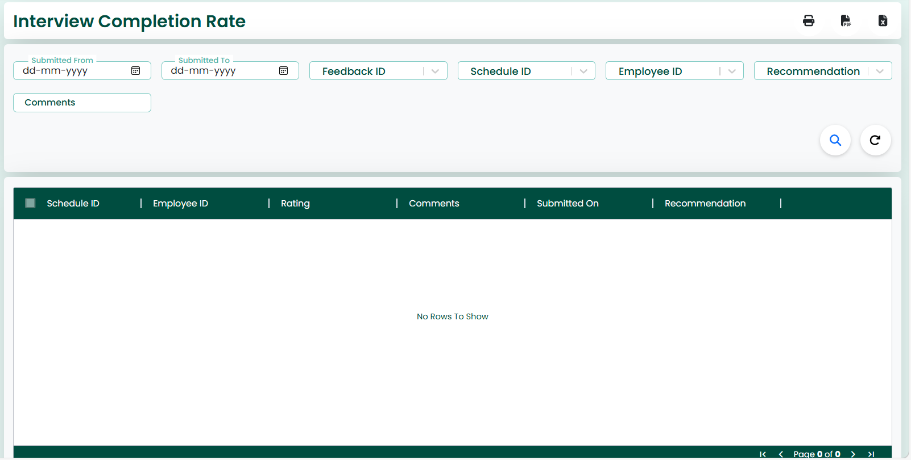
Action Button:
✧ This screen also features Print, PDF, and Excel icons located at the top-right corner.
✧ The Print icon is used to print the interview completion report.
✧ The PDF icon allows the user to download the report in PDF format.
✧ The Excel icon is used to export the report data into an Excel file.

Search Criteria
✧ This screen provides a Search Criteria section to retrieve interview completion records.
✧ The user can search the data using the following fields:
- Submitted From
- Submitted To
- Feedback ID
- Schedule ID
- Employee ID
- Recommendation
- Comments
✧ After entering the search criteria, clicking the Search icon will display the matching completion records.
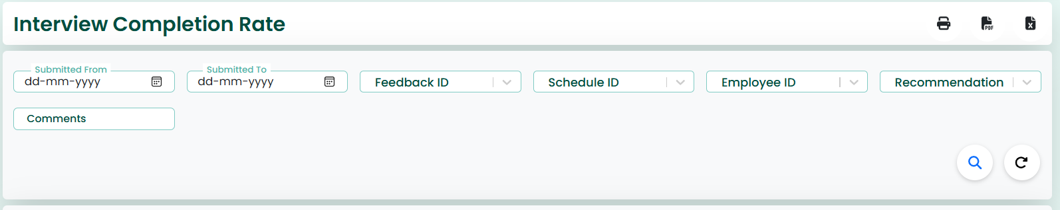

Action Button
✧ The Search icon is used to fetch filtered interview completion records.
✧ The Reload icon clears all search fields and reloads the data.

Data Grid
✧ The interview completion records are displayed in the grid below the search section.
✧ The grid shows details such as Feedback ID, Schedule ID, Employee ID, Recommendation, Comments, and Submission Date.
✧ Each record includes a checkbox for selection.
✧ The grid provides a structured and easy-to-read view of interview completion data.

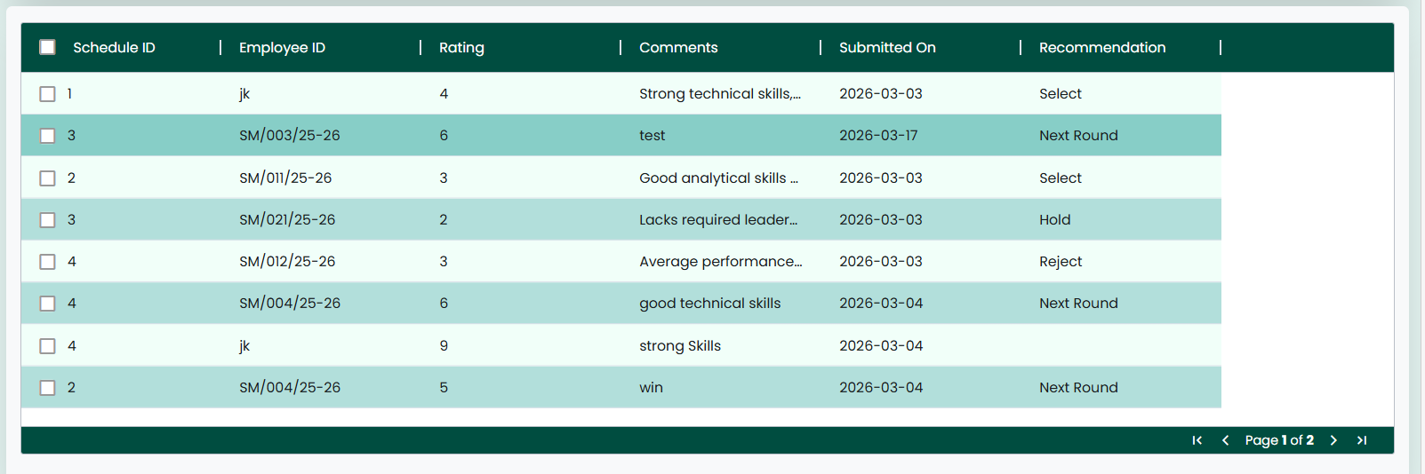

Action Button:
✧ The Reload button/icon can be used to refresh the page, clearing all fields and resetting the screen to its initial state.

